UDConnect in practice

The following is a concrete usage scenario, which details the procedure for extracting transaction data from an ORDERS table in a MySQL database using UDConnect. There is also more information concerning the BI Java Connectors and additional resources listed at the very end of the document. MySQL provides a JDBC-compliant database driver which can be used with the UDConnect interface. The procedure demonstrated in this example will be very similar for any other database or source that provides a JDBC driver.

In this example, a new database named “Sales” was created. The database contains four tables:
- CUSTOMERS
- ORDERS
- PRODUCTS
- PROMOTIONS

The structure of the orders table is displayed in the MySQL terminal monitor as follows:

mysql> describe orders;
+----------------+-------------------------+------+---------+---------+-------+
| Field | Type | Null | Key | Default | Extra |
+----------------+-------------------------+------+---------+---------+-------+
| OrderID | varchar(5) | YES | | NULL | |
| customerID | varchar(20) | YES | | NULL | |
| ProductID | smallint(5) unsigned | YES | | NULL | |
| OrderDate | date | YES | | NULL | |
| UnitPrice | decimal(6,2) | YES | | NULL | |
| Quantity | smallint(5) unsigned | YES | | NULL | |
| Discount | decimal(6,2) | YES | | NULL | |
+---------------+--------------------------+------+---------+---------+-------+
7 rows in set (0.00 sec)

Figure 1 below shows how the configuration of our sample database looks in the MySQL Administrator for Windows:

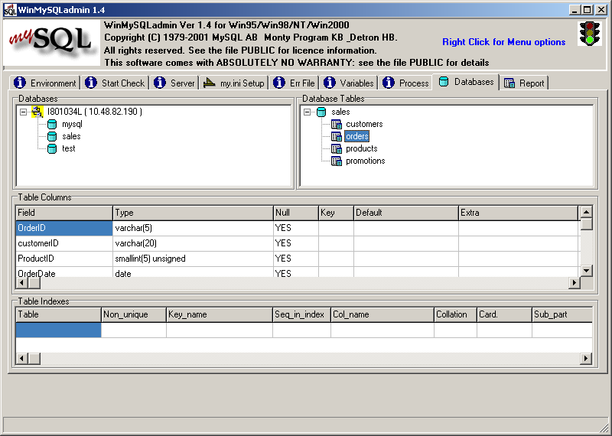
Figure 1: The MySQL database Administrator

Configuring the source database connection (SAP J2EE Engine Administrator)
Before connecting to the ORDERS database table from the SAP BW system, a few steps are necessary in the SAP J2EE Engine Administrator (Visual Administrator throughout) to setup the connection to the MySQL source database. The Visual Administrator is a graphical user interface (GUI) which allows you to administer relevant Java services and provides tools for remote monitoring and management of these services.
The steps detailed below are:
- Installation of the JDBC driver
- Configure the database connection
- Configuring the SAP BW RFC destination

Step I: Install the JDBC driver
In order to use the JDBC driver provided by MySQL it must be installed on the J2EE engine via the steps outlined below.
- Start the Visual Administrator. The Connection dialog box appears.
- To view SAP J2EE Engine components, expand the Cluster root element in the left-hand pane.
- Expand the Services node and choose the JDBC Connector service from the list of services.
To deploy the JDBC driver, use the Runtime tab of the JDBC Connector Service.
- Choose Resources → Drivers.
- Choose Create New Driver or DataSource on the toolbar.
- Specify a name for your driver entry, such as MYSQL. (See Figure 2)
- Browse to the archive file that contains the classes of the driver (supplied by the JDBC driver vendor). In the example, the MySQL JDBC driver is in a single JAR file: mysql-connector-java-3.0.10-stable-bin.jar. For other drivers, additional files can be chosen if necessary. (See Figure 3)

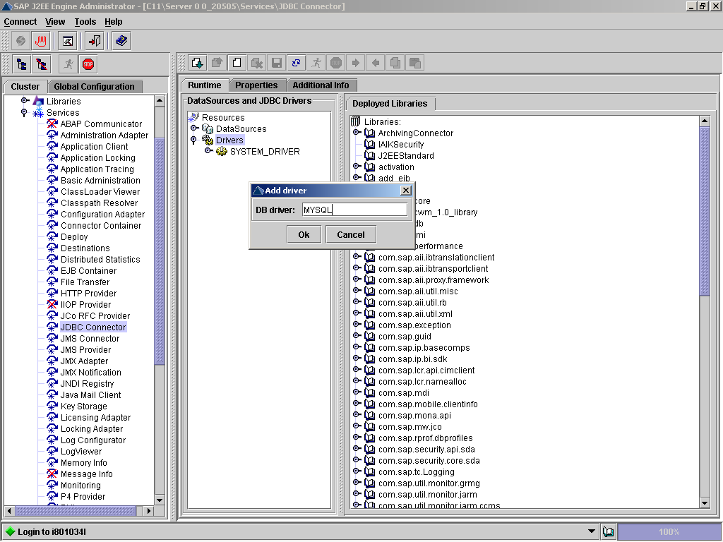
Figure 2: Installation of the JDBC driver with the JDBC Connector service

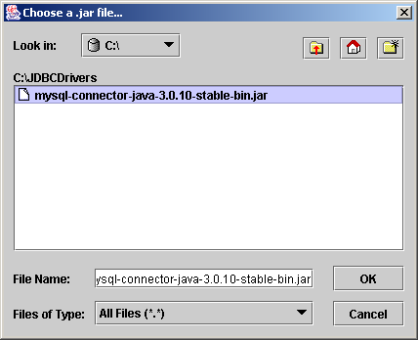
Figure 3: Selection of the JDBC driver libraries

Step II: Configure the database connection

The configuration of the connection to the example database is accomplished via the Connector Container service. The Connector Container Service manages the overall connectivity to back-end resource systems and provides a runtime environment for resource adapters that enable connections to heterogeneous EISs.

- On the Cluster tab, choose the Connector Container service.
- Under the Connector 1.0 folder, select the BI_JDBC_CONNECTOR node.

NOTE: With the default installation of UDConnect and the BI Java Connectors, preconfigured connections for the connectors are installed (including this BI_JDBC_CONNECTOR). The default connection parameters in the respective connector must be set to the specifics of particular source environment (hostname, database name etc.). Connectors can also be cloned to create additional connections. This allows additional configuration of connections to other JDBC data sources.

Continuing with the example, the default connection parameters of the BI_JDBC_CONNECTOR must be changed to access the Sales database in the MySQL environment.

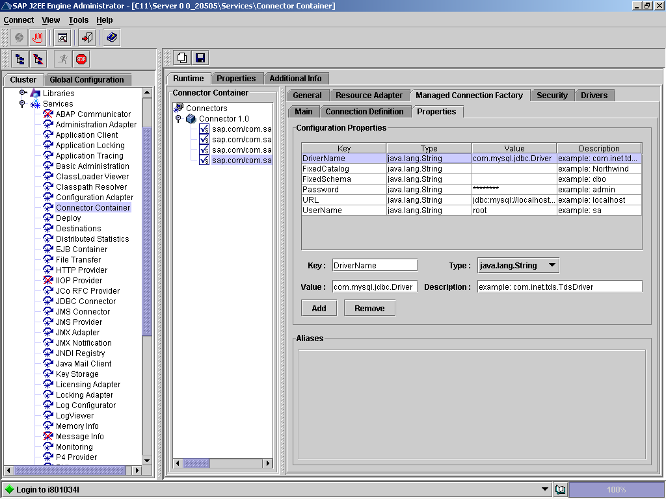
Figure 4: Editing the Properties of the Managed Connection in the Connector Container Service
- Choose the Managed Connection Factory tab, then the Properties tab (see Figure 4).
On this tab, configure the database- and driver-specific connection parameters that are required to establish a physical connection with the database server:

  - Connection URL (for example, jdbc:mysql://localhost/sales, a URL which specifies connection and also selects the sales database)
  - Driver name (for example: com.mysql.jdbc.Driver)
  - User name
  - Password
As in other extraction scenarios, UDConnect uses a single fixed user that is configured here for the access of the source database.

To allow the BI JDBC Connector to access the MySQL JDBC driver, a loader reference must be added which points to the driver’s class libraries to the connector's configuration:

- Choose the Resource Adapter tab, then the Add button to the right of the list with the Loader References.
- In the Enter a name for new component dialog, enter library:MYSQL (library: <name of JDBC driver in Step I.6 above>). (See Figure 5).
- Confirm with OK and save changes by choosing the Save button on the toolbar of the service.

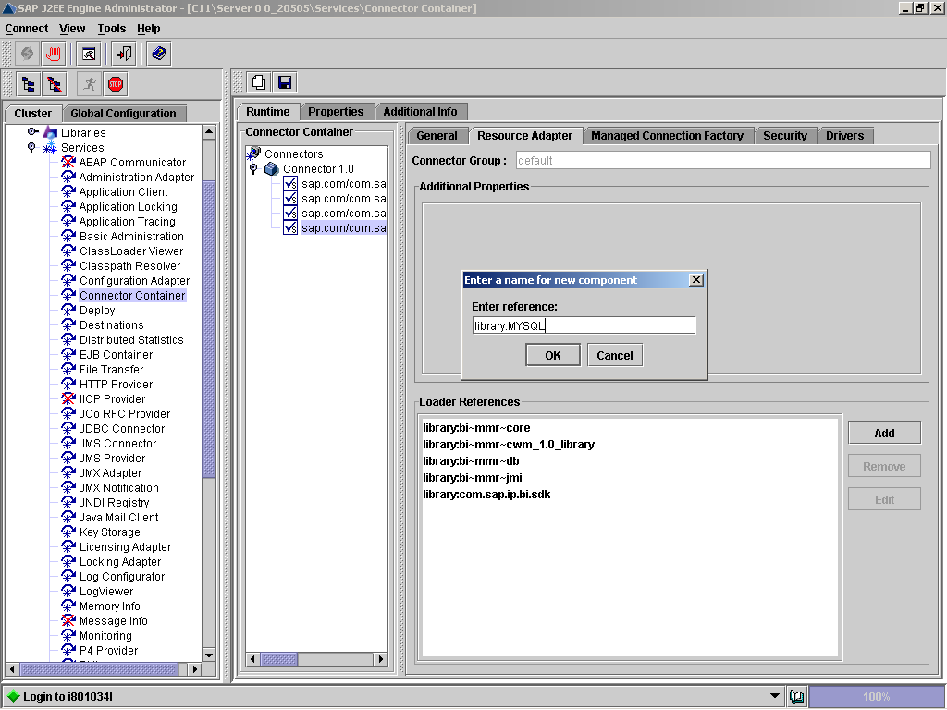
Figure 5: Adding a loader reference that points to your JDBC driver's class libraries

Step III: Configure the SAP BW RFC destination
As outlined in the architecture section, the UDConnect extraction process is based on generated generic DataSources using ABAP function modules. To enable calls from the SAP BW server's ABAP stack to the J2EE engine on which the UDConnect application component runs, the J2EE Engine must be registered as an RFC destination.
Note: In the SAP J2EE Engine, the RFC functions are implemented by the JCo RFC Provider Service, which is used for processing ABAP-to-Java requests. The JCo RFC Provider Service processes calls from the SAP systems and dispatches the calls to stateless session beans, in our case the UDConnect J2EE application component. Technically, the service is based on JCo (SAP Java Connector).
To register the SAP BW system as an RFC destination, use the J2EE Engine Visual Administrator and select JCO RFC Providers from Services and then the Runtime tab. This tab contains three panes – Available RFC destinations, RFC destination, and Repository (see Figure 6).
Use the RFC destination pane to register the SAP BW system as a new destination:
- Choose the Program ID field and enter BIUDCAB5. The ProgramID can be freely chosen by you; however it needs to match the configuration of the RFC destination on the SAP BW side. In this example, the naming convention used is BIUDC<sysid> where <sysid> is the 3-letter SAP BW system identifier-- AB5 as shown here.
- In the Gateway host field, specify the host of the gateway through which the requests are passed.
- In the Gateway service field, enter the gateway service that will receive requests for handling JCO functions.
- In the Number of processes (1 to 20) field, specify the number of JCO Servers started.

To complete the setup of the RFC connection between the SAP BW system and the J2EE engine, a matching RFC destination must be created on the SAP BW side in transaction SM59. Follow the steps below to do this.

- Logon to the SAP BW system and start transaction SM59, “Display and maintain RFC destinations” (See Figure 7).
- From the toolbar, choose Create.
- In the maintenance screen of the RFC destination, enter a name for the destination. Choose any valid name. NOTE: this name is used later to identify the J2EE engine on which UDConnect is installed when creating the SAP BW DataSource.
- For the type of the destination, choose T for a TCP/IP Connection.
- For the activation type, choose the Registered Server Program option, and enter the chosen in the ProgramID value from above; for example, BIUDCAB5. This ID must match the ProgramID used in the JCo Provider Service of the J2EE Administrator (see Step 1, above).
- Enter values for the Gateway Options (host, service).
- Save and test the connection.

The MySQL database is now connected to the SAP BW server.

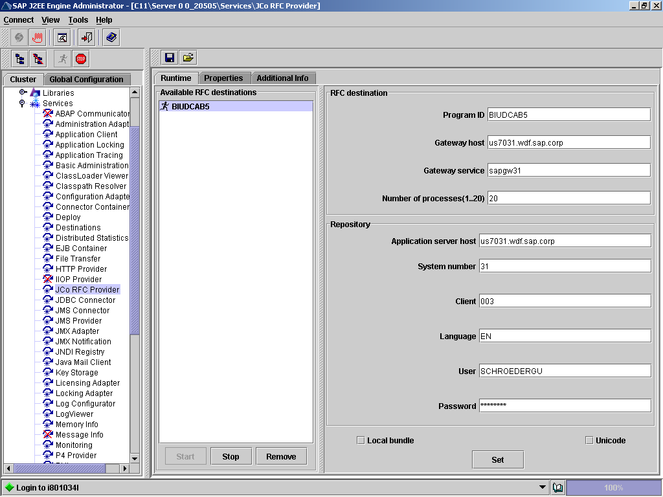
Figure 6: Configuration of the SAP BW server RFC destination
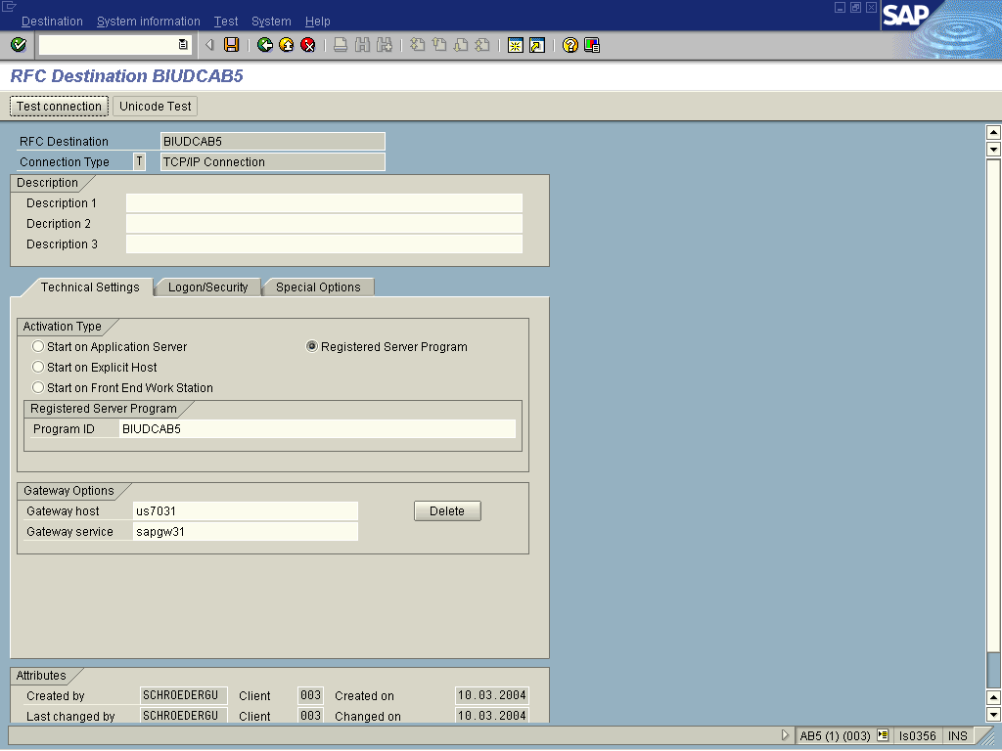
Figure 7: Configuration of the RFC Destination on the SAP BW side with transaction SM59

Create DataSource and InfoSource

The creation of an InfoSource and the DataSource that accesses the ORDERS table in the MySQL database is straightforward. Only those steps of the process in which new features have been added to support the access of the remote database via UDConnect are highlighted here.

- In the InfoSources modeling area of the Administrator Workbench, create a new InfoSource.
- In the Create InfoSource dialog box, choose the option Flexible Update in any Data Target and enter a name and a description for the InfoSource.

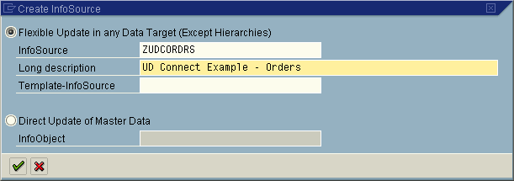
Figure 8: Create InfoSource with flexible update

  - Maintain the communication structure of the InfoSource by selecting the required InfoObjects. Standard content objects were used and can be seen (along with technical information) in Figure 9.

- Connect the InfoSource to the source database:
The DataSource required for this can be generated. This is a new feature provided as part of the UDConnect interface.
From the Extras menu, select Create BW DataSource with UDConnect (see Figure 9).

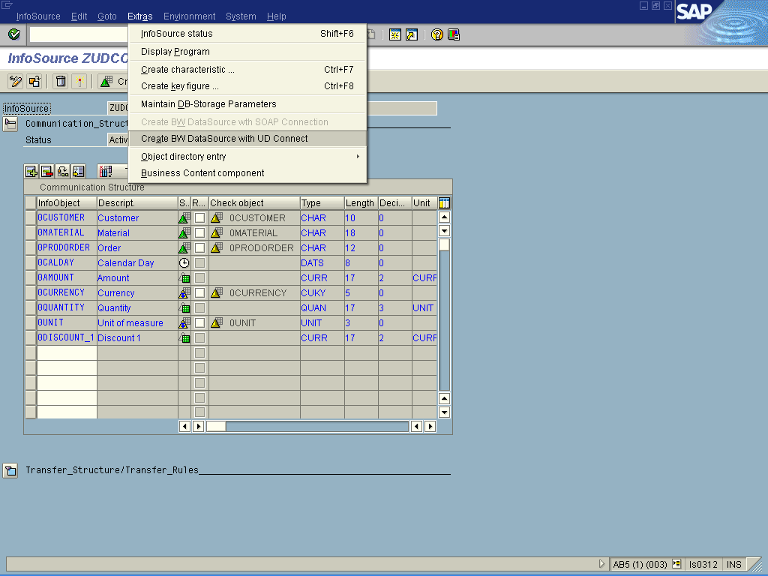
Figure 9: Maintain InfoSource

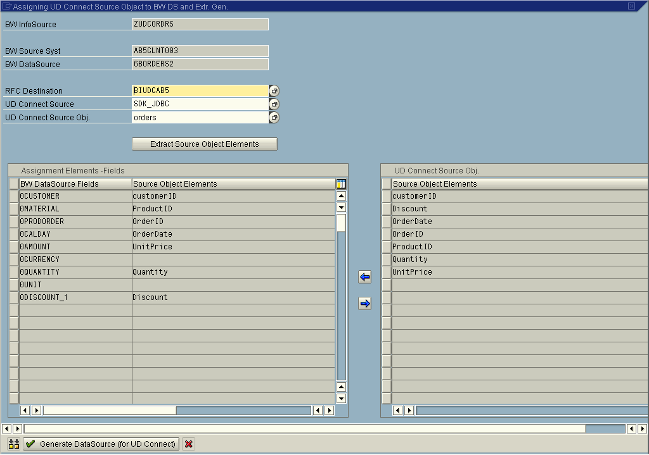
Figure 10: Assigning Source fields to fields of the communication structure

The Assigning UDConnect Source Object to BW DS screen appears, as shown in Figure 10. Enter information in the RFC Destination, UDConnect Source, and UDConnect Source Object fields, as below:

- RFC Destination:
In this field, enter the name of the RFC destination you created with transaction SM59 (see Step III.7 above). This identifies the connection to the J2EE engine on which the UDConnect component has been deployed.
- UDConnect Source:
In this field, enter the name of the connection created with the Connector Container service. This identifies the database connection you are going to use.
- UDConnect Source Object:
In this field, enter the name of the table from which you want to extract data. The input help for this field provides you with the list of tables in the connected database. In our example, it lists the four tables in the sales database (customers, orders, products, and promotions). (See Figure 11). In this example, ORDERS was selected into the field.

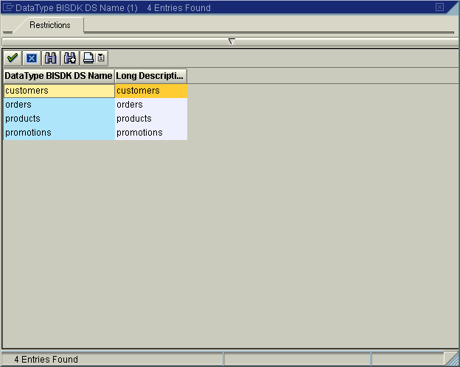
Figure 11: Value input help for the UDConnect data source object

The system requests the column metadata for the orders table from the UDConnect application component and populates the Source Object Elements list with the column names of the order tables. Note that some mapping assignments are automatically proposed based on column names as well as data types.

Note: The mapping proposals are based on heuristics rather than exact matches, to simplify input work. If a proposed mapping is not what is desire, you can always remove a mapping.

Assignments can be deleted and added by marking an InfoObject of the communication structure on the left side and a source field/column on the right side and using the shuttle buttons (<-, ->).

- Enter or accept default assignments for all fields.
- When assignment is complete choose Generate DataSource for UDConnect from the toolbar (button shown at the bottom of Figure 10).
This generates an ABAP extraction function module according to the rules for generic extractors as well as the required dictionary structures.
- After a short compilation time, the system prompts confirmation of the assignment of the generated DataSource to the InfoSource. Select Yes and the system informs should return a message indicating successful creation.

A name for the DataSource is chosen according to the following convention: 6B<source_name><#>, e.g. 6BORDERS3. The number at the end allows for resolving naming conflicts in case multiple DataSources for the same source object are generated. You can also lookup the generated extraction function module in transaction SE37to inspect the code which has been generated.

- Set the Currency and Unit InfoObject values to constants.

Change to the Transfer Rules view within the InfoSource maintenance screen.

Click on the “Edit Transfer Rules” button () for 0CURRENCY and set a Constant value of USD (or a currency known to be maintained on your system).

Repeat this for 0UNIT and set it to EA (or a Unit of Measure known to be maintained on your system).

In this example, the Conversion check box (not pictured—scroll to the far right in the “Communication Str./Transfer Rules” pane of the Transfer rules dialog) was selected for 0CUSTOMER and 0PRODORDER because these fields are shorter in the database than the field length in SAP BW. The Conversion will pad spaces to right align the values in the InfoObjects.

- Finally, activate the InfoSource
- Connect the InfoSource to the DataProvider of choice. Some guidelines follow:

- By creating a Remote Cube against this InfoSource (right mouse click on the InfoSource and select “Create Remote Cube”) a transient data staging scenario is created whereby data is accessed dynamically via the InfoSource, through the BI Connector and sourced from the remote data source in real time.
- By creating a Basic Cube or ODS (Operational Data Store) object against this InfoSource a persistent data staging scenario is used (e.g. an InfoPackage must be created and the job scheduled, data is physically transported and persisted in SAP BW).
- In all cases, Master Data must be persistently stored on the SAP BW system if texts/attributes/hierarchies are to be available for reporting.

- Regardless of the DataProvider type chosen, once data is properly staged, Business Explorer (BEx) queries can be executed against this newly created object.

For all processes ”above” the InfoSource level it is completely transparent that the DataSource is pulling data from the UDConnect application component and a remote database.

SAP Query BI Connector

Another relational BI Connector supplied by SAP can source data from SAP Queries (SAP BASIS 4.6C and above). In its current form the SAP Query BI Connector does not offer significant advantage over the SAP delivered Service API (SAPI) functionality for Generic Extraction. The SAP Query BI Connector is fully functional in SAP BW 3.5 and can be leveraged by customers wishing to use Java-based connectivity rather than traditional tRFCs.

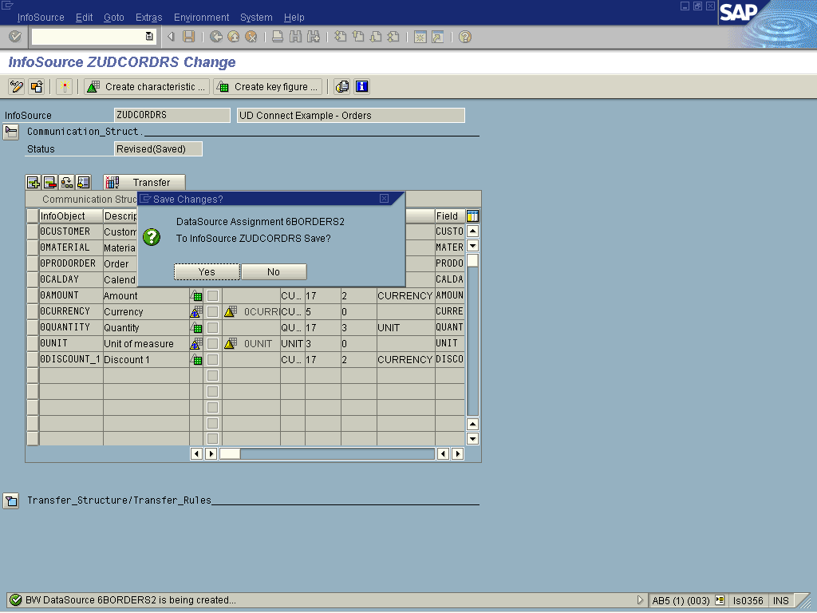
Figure 12: Prompt to confirm the DataSource assignment

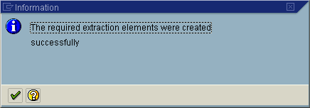
Figure 13: Success message after completion of the workflow

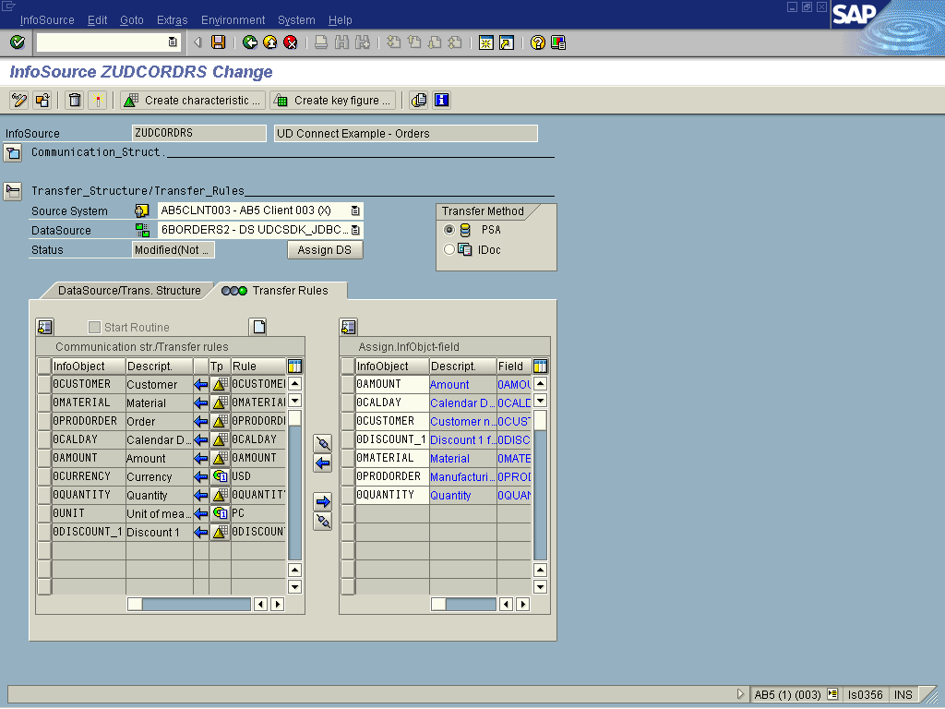
Figure 14: Transfer Rules for the generated DataSource

More about BI Java Connectors and extraction from OLAP sources

The SAP BW extraction APIs support flat (tabular) views of data. Therefore, the extraction from an external database via JDBC as shown in the previous section is straightforward. Columns of the JDBC source table are mapped to fields in the transfer or communication structure respectively; in addition, data types are mapped from Java types to matching ABAP data types.

As mentioned in the architectural overview, two additional BI Java Connectors for multidimensional data sources are also provided with SAP BW 3.5:

- The BI ODBO connector supports connectivity to OLAP servers such as MS Analysis Services or SAS using the respective OLE DB for OLAP providers of these servers. This interface technology is restricted to a Microsoft Windows environment; in other words, the BI ODBO Connector can only be deployed on a J2EE engine running on a Windows system, because native libraries are required.
- The BI XMLA connector supports connectivity to OLAP servers based on the XML for Analysis API. In contrast to ODBO, this API is platform neutral, and hence can be used on any platform. As of the writing of this article, server products that support this standard have been released by Microsoft, Hyperion, and SAP. Other members of the XML for Analysis council are also working on releasing products in the near future.

The full list of BI Java Connectors supplied with SAP BW 3.5 appears below:

Technology based on
Relational
OLAP
Provides access to
BI Java Connector
Sun's JDBC -- the standard Java API for RDBMS.
Connectivity to over 200170 JDBC drivers,
Examples:
Teradata, Oracle, Microsoft SQL Server, Microsoft Access, DB2, Microsoft Excel, text files such as CSV

BI JDBC Connector

Microsoft's OLE DB for OLAP -- the established industry-standard OLAP API for Windows.
OLE DB for OLAP-compliant data sources
Examples:
Microsoft Analysis Services, SAS, Microsoft PivotTable Services

BI ODBO Connector

Microsoft's XMLA -- Web services-based access to OLAP providers.
Platform-independent access to BW 3.x and other OLAP data sources
Examples:
BW 3.x, MS Analysis Services, Hyperion, MicroStrategy

BI XMLA Connector

SAP Query -- a component of SAP's Web Application Server
SAP operational applications
Examples:
data in transactional systems such as R/3, Ad-Hoc, and Operational Reporting

BI SAP Query Connector

Figure 15: BI Java Connectors

The extraction from multidimensional OLAP sources require some additional explanation, since the multidimensional structure of a cube exposed by an OLAP data source does not directly map into flat extraction structures as utilized by the BW extraction interfaces. Therefore, cubes are transformed through a process called flattening into view-like tabular structures that map easily into a flat transfer structure.

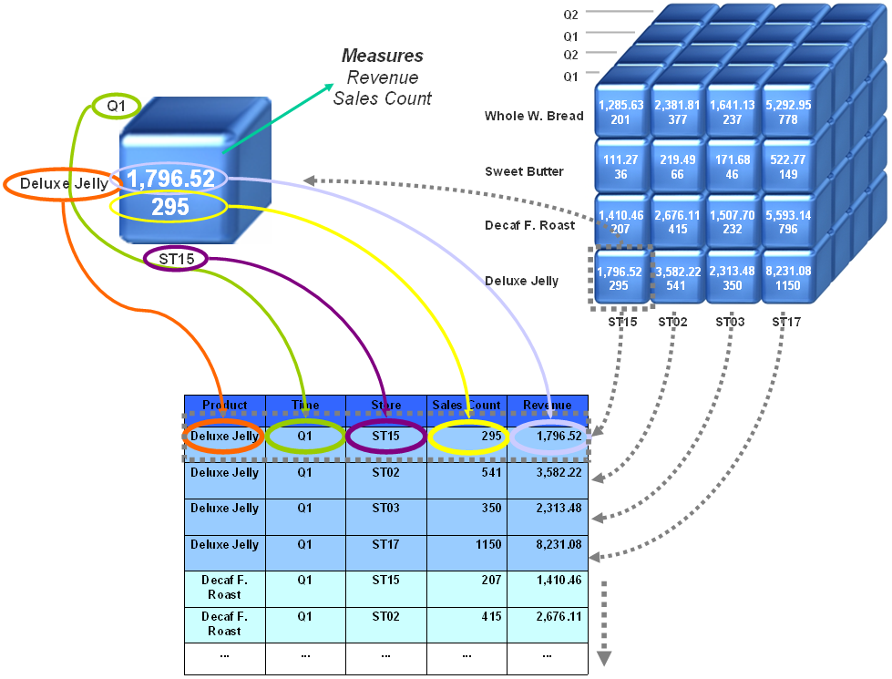
Figure 16: A sample cube to demonstrate flattening
In order to illustrate this process Figure 16 outlines a simple 3 dimensional cube. Each of the cube’s three dimensions (Time, Store, and Product) consists of a set of related members or characteristic values. In this visualization, the edges are formed by the values of the different categories that form the key. The cells of the cube, formed at the intersection of coordinates of all categories (representing a particular value tuple), contain the measures.

A cell represents data values and their relevant attributes; for example, in referring to Figure 16 above, store ST15 booked certain revenue and sales count for the product Deluxe Jelly in the timeframe of Q1. The revenue and sales count values are contained in the cell.

Also note how the members of the time and store dimensions are arranged in hierarchical structures with levels such as Country, State, City, and Store for the Store dimension.

To flatten a cube, the BI Java Connectors use the following approach:

For each dimension, the lowest level is chosen from the dimension's default hierarchy. Each of these levels result in one field per dimension for the flat target structure. In the example, this yields the Time, Store, and Product columns. Note that the name of the dimension (not the name of the level) is chosen for the column name. The data type of each resultant column is character. Furthermore, one column is created in the target structure for each measure -- Revenue and Sales Count in the example. The data types of the measure columns correspond to the data types of the measures in the cube; for example, Integer for Sales Count and Currency for Revenue. The resultant flat table is shown at the bottom of Figure 16 which basically corresponds to the fact table of the cube.

Resources

JDBC Data Access API Drivers
http://servlet.java.sun.com/products/jdbc/drivers/index.html

XML for Analysis www.xmla.org

Further information on SAP BW 3.5 Functionality: http://service.sap.com/bw

The MySQL database platform was purposefully chosen to allow the reader to follow thru the example. The MySQL database can be downloaded for free at http://www.MySQL.com/downloads/index.html. Note that the examples in this article are shown for the Microsoft Windows platform.
Refer to the vendor’s JDBC driver documentation for specific syntax.
NOTE: The gateway settings need to be verified with your Web AS administrator for your specific settings.
This is a standard naming convention for generated datasources in SAP BW. 6B indicates a DataSource generated for UDConnect. 6A, for example, indicates a DataSource generated with a SOAP interface for XML.
Note that the function module name is in the format: /BI0/RSUDC_EX1_6B<DataSource name><#>

