Deduction Management Component


by Keith Hibbits, SAP Platinum Consultant

OK … I know. Trying to manage A/R balances in R/3 can
be a rather difficult task sometimes, but only if you’ve got customers out there who don’t pay their total amount due. But then again, maybe you’re lucky enough to have customers who pay you what they’re supposed to pay (in other words, what they owe) as opposed to what they think they should pay you.

I’ll guess, however, that you’re like all the others out there in the normal A/R and Credit world who need a way of tracking short or partial payments and documenting what actions have been and are being taken.

And as I said earlier, I know. Because I’ve been there. In a prior life I was responsible for over $70 million a month in Accounts Receivable, so I understand where you’re coming from with your thoughts about managing A/R balances.

Having introduced the problem, allow me to introduce you to the solution when it comes to A/R management in SAP R/3. The answer is additional A/R functionality that SAP’s Global Solution Center provides via a product called Deduction Management Component, which is a 'bolt on' component that enhances the functionality of the SAP R/3 Accounts Receivable module, specifically within the areas of partial payments.

When added to your SAP R/3 system, the Deduction Management Component allows you to track, interpret, record, and manage the life of an A/R document or account. The sheer volume of documents often prevents accurate tracking and settling of payments to invoices, specifically when it comes to short or partial payments. The result is large expenditures for labor, falling behind in record keeping, unnecessary outstanding balances or all the above. The Deduction Management Component allows you to accurately track deductions taken for whatever reason a customer may deem fit.

Let me describe something that you most likely already know … how standard SAP Accounts Receivable functionality works. In standard SAP A/R, the R/3 system uses open and closed items (journal entries) to calculate account balances. The two ways core A/R works for short payments is either by residual item or by partial payment. Residual Item posting clears the original item and creates a new document that is the difference in the amount that was owed and the amount that was received. Partial Payment posting does not clear the original item. It simply applies the amount of cash received to the amount owed without any clearing whatsoever.

What the system does not provide, however, is a method to view the inter-relationships among various A/R line items. If you create a residual document or entry from the original A/R document, you see only one level of linking. Both the residual item and partial payment options have reference between the payment and the document with which it is associated. But beyond that one level of reference, there is no linking to other documents. And just think what happens if you’ve got even more partial payments (residual entries) that are associated with that original document. There’s no way to tie those all back together to get an idea of what has taken place over time. Standard A/R functionality also does not give the option to note any action that is taken against a line item. For example, if a debit is overdue and someone has called the customer it is not easily noted or identifiable.

Table 1 depicts a business scenario using t-accounts showing debits and credits
for the entire Deduction Management Component example.

Customer Account Cash_________
- 5,000 1) 4,000
- 1,000 2) 500
- 500

Document Flow for a residual item:
- Invoice issued to customer for $5,000
- Payment made payment of $4,000 that was less than the original invoice,
thus creating a residual item
- Credit memo issued for $500 for damaged goods leaving a balance due
of $500

The Deduction Management Component was developed to better manage these various parts of Accounts Receivable. DMC has several parts (which I discuss in greater detail below): Document Flow, Document Owners, Notes Tickler, and Credit/Debit Offset.

Document Flow within the Deduction Management Component has the same functionality as a sales order document flow. It allows the user to view the entire chain of inter-related documents associated with an A/R transaction. For example, the entire document chain may consist of a billing document, a partial payment, a credit memo, another payment, and so on. The linking of these individual documents creates the document flow, the history of which can be seen using the Deduction Management Component A/R Document Flow functionality. This Document Flow allows the user to view all related documents on the same screen for easy follow-up, something currently not available in core R/3.

Figure 1 shows the Document Flow functionality in Deduction Management Component.
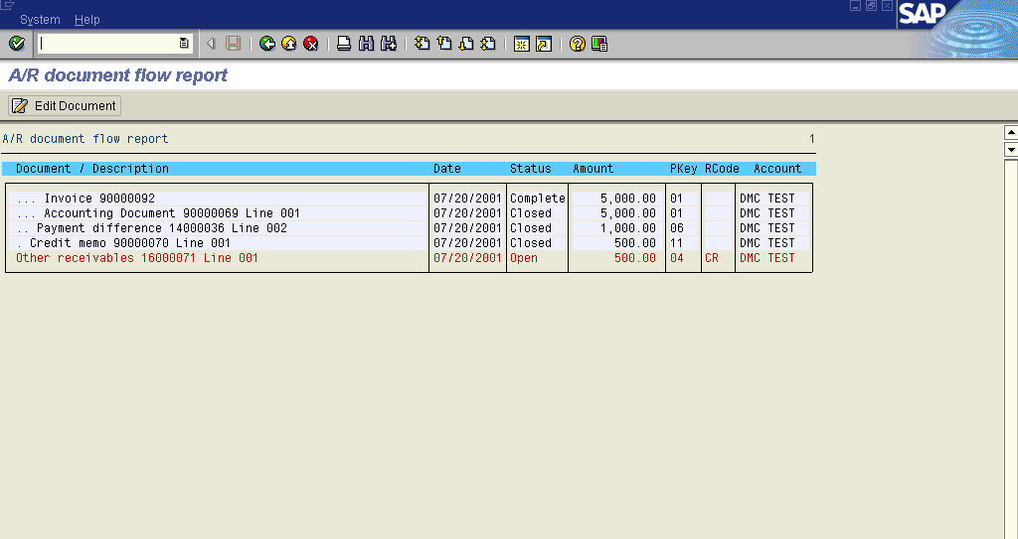

Both open and closed items are identified in the Document Flow list. It will reference, if available, the Sales Order Document, Delivery Document, Invoice Document, and all Accounting and Clearing Documents. It shows dates the documents were created, status (open or closed), document amounts, posting keys used when documents were posted, reason codes for the posting and the customer account number.

The interactive functionality of the Document Flow screen allows the user to navigate directly to any document represented on the screen simply by single-clicking on the particular item listed. For example, if the original sales posting stems from the Sales and Distribution (SD) module, the SD side of the document flow can easily be accessed by single-clicking on the invoice from within the FI/AR Document Flow. This works for all documents in the flow: each one is just a single-click away.

Note: Standard SD Document Flow will not reference amounts. Having this in the A/R Document Flow is a plus you can’t get in SD.

Debit/Credit Offset allows the user to create a credit with reference to a debit, run an ABAP report that clears both the debit and credit, references both in a document flow, and creates a residual item. The Debit/Credit Offset functionality is possible in both the A/R and Sales Distribution modules. For example, in SD the Debit/Credit Offset allows a user to link a credit memo being entered to an already existing open debit document that is posted to the customer.

The functionality also allows the user to match up multiple debits and credits, even when the amounts are not identical; the Deduction Management Component allows the settlement of these partial payments. The credit amount can then be allocated among the various debit documents displayed from the customer's account, or it may be applied to a single debit document as desired.

The biggest thing to know about the Debit/Credit Offset is that it has to be used (is mandatory) so that documents are included in the Document Flow. This functionality is where the linking of the documents in the flow occurs. If you don’t use the Debit/Credit Offset when posting a transaction, either in SD (credit memo) or FI (cash receipt, credit memo, etc.), the document will not be reflected in the list of documents in the Document Flow.

Document Owners record who is responsible for monitoring individual line items. A user can specify owners of particular document items by account. These line items could be directly linked to “owners,” such as the sales representative, credit management personnel, or the A/R accountant responsible, based upon SAP’s concept of partner functions. With the Deduction Management Component, the accounting document line item features a new button that displays a popup where an unlimited number of owners and their associated partner functions can be assigned. Deduction Management Component functionality also allows for the establishment of default Document Owners. These Document Owners may be assigned to an A/R account and will be defaulted to all documents posted against the account. These defaults may be overridden.

Figure 2 shows the Owner for the document line item. Also notice the additional buttons at the line-item level that the Deduction Management Component functionality adds: Document Flow, Notes, and Owners.
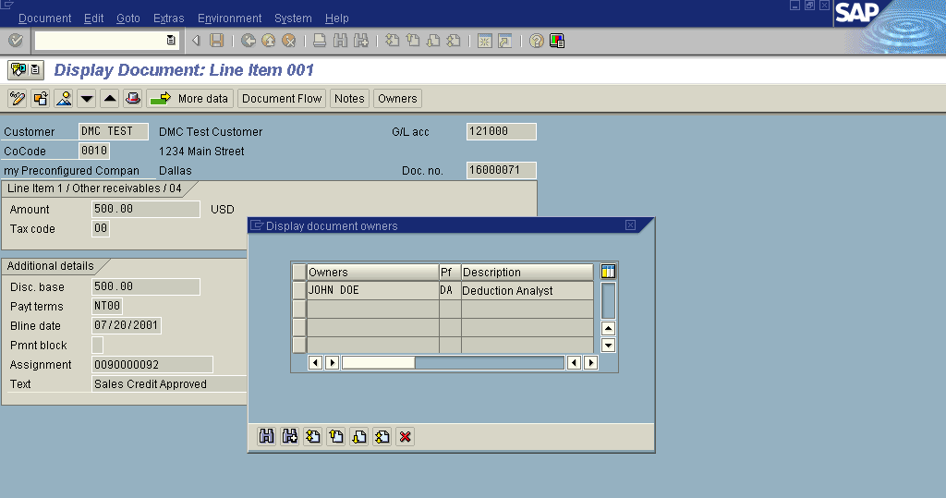

For example, the document shown in Figure 2 (above) has been assigned to John Doe, a Deduction Analyst. If a Document Owner is changed for a specific account, then all subsequent documents posted to the account will reflect the new Document Owner. It is also possible to assign more than one Document Owner to an account. However, each Document Owner assigned must have different functions. There can be an unlimited number of Document Owners assigned to a single customer account.

Furthermore, any changes to a Document Owner of a specific document will also be reflected to all future documents posted against the current changed document. For example, an invoice is posted to a customer account. The default Document Owner is John Doe. Next, the user edits the invoice document item and changes the Document Owner to Jane Doe. Now, all future postings to this invoice will have Jane Doe as the Document Owner, and not John Doe.

Note: The Document Owner of any document can be changed only if the document is still open, that is, if the document is not cleared. Document Owners are configured and assigned to accounts under the Deduction Management Component Master Data Maintenance.

Notes Tickler functionality within the Deduction Management Component allows users to attach specific “action items” and the person who will do the action to either A/R documents (either at the document line item or header level) or accounts. By doing so, SAP will now be able to provide a means of obtaining a “historical action log” and a “to-do” list of upcoming required activities. Priority can be assigned to each “Action Item” entry that is created by the user based on the situation that arises. Actions attached to A/R items will provide a means of tracking customer and document activities (e.g., retransmissions of invoices, phone conversation logging, general customer comments, and other various configurable activities such as “promise to pay,” “proof of delivery requested,” etc.). Generally, these actions can be grouped into two broad statuses — either they are completed (action taken), or they have yet to be performed (action required). These actions contain texts and several different dates and have amount fields associated with them. While adding texts and actions to an item or account, the user can assign the action to a specific user or group of users.

Figure 3 depicts the overview of the note, or notes, for a particular document line item.
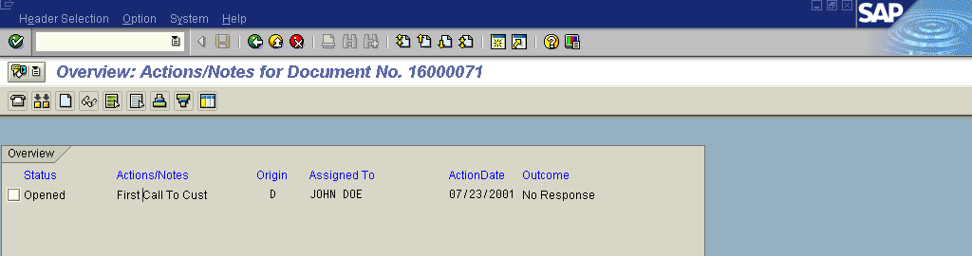

Figure 4 shows the detail of the previous note overview.
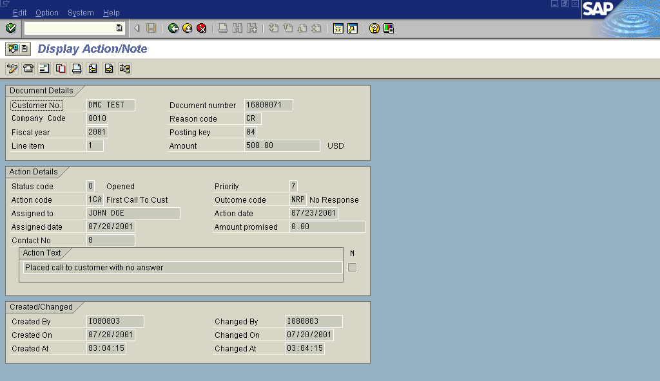

Access to the Notes Tickler Create/Change screen can be accomplished by clicking on the Notes button while changing an account line item of a particular A/R document, from the Customer Master transactions (FD03, XD03 or FD33), or from the Notes Tickler transaction itself.

Reflected in the Notes Tickler area are such designations as: Status Code, Priority, Action Code, Outcome Code, Assigned To, Action Date, Assigned Date, Amount Promised, Contact No., Action Text, and Person who created/changed the Note. Many of these fields are freely definable in terms of data definition for the field itself. For example, you’ll have various status codes that will be defined in addition to possibly several priority levels, action codes, outcomes, etc.

Once the details of the action are completed and saved, the Notes Tickler will record the details and then display the list of all actions for that document. To add more action items, just repeat the previous steps, and each action item will be listed along with the others. If desired, the creation of a Notes Tickler action can also be set up to trigger Workflow if configured.

Note: The Origin column signifies where the action item was first originated. There are four areas where a note can be created:

- Client Level (C) — This is a note entered at the account level. It is accessed via the Notes button while displaying the Address data of a customer's Master Record without entering a Company Code.

- Document Level (D) — This is the most common way of creating a note. It is accessed via the Notes button while displaying a document's customer item details.

- Credit Control Area Level (K) — This is a note entered on the Customer's Credit Management screen. It is accessed via the Notes button while displaying the Status data of a customer's Credit Control Area Data.

- Company Code Level (O) — This is a note entered in the same way as the Client Level note except that a Company Code is entered first on the customer's Master Record.

The specific actions and responsible persons can be displayed in three different reports: “To-Do List” (used for upcoming required activities), “Document List,” and “Documents without actions.” You can assign priorities to your action items as needed. Notes Tickler enables you to retrieve, view, and report all notes and actions. You can also create new actions or change existing actions within the Notes Tickler.

The Notes Tickler Query function will enable retrieval, viewing, and reporting off of the notes and actions created by the Notes Tickler Create/Change function. It will also be possible to create new actions and change, or mass change, existing actions. There are four selections for the Notes Tickler Query: To-Do List, Document List, Documents without Actions, and Other Reports.

Figure 5 shows the Notes Tickler/Query overview screen.
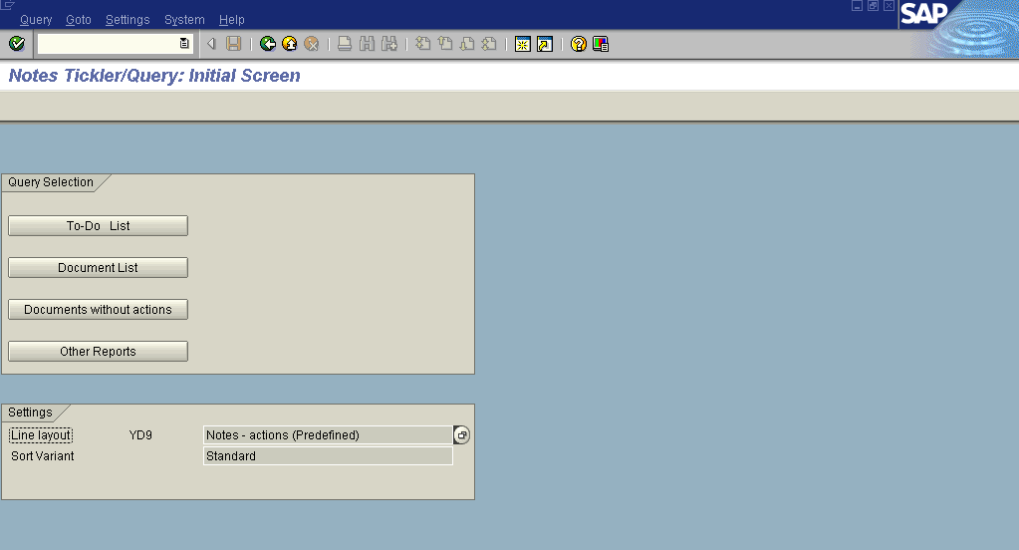

To-Do List: The Notes Tickler will provide for a user (default Assigned To) a list of those actions that are open (“O”) as default. The list contains both the document notes and the customer notes. The layout of the report is selectable by the user and can be sorted by document number, item number, action priority, customer number, etc. From the To-Do List report screen, the user can select one or more items to display or change, or the user can do a mass change on all the documents selected.

This report would be perfect for use by an analyst who needs to work past due items that were set with a future date. The report would be run first thing in the morning for a given owner (analyst) for open items with that particular action date.

Figure 6 shows the To-Do List based upon the parameters set, such as Owner, Action Status, Action Date, etc.
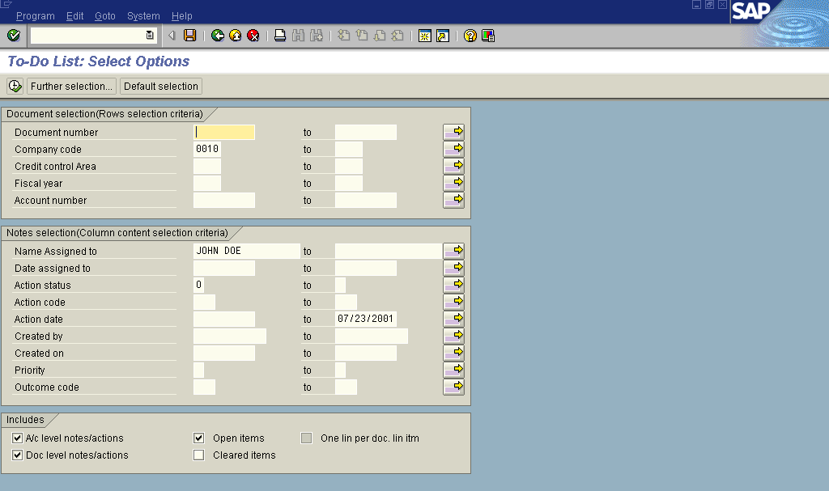

Figure 7 shows the executed report. You would them have a list of work items which you would work and have immediate access to the details of the work items by double clicking on the item.
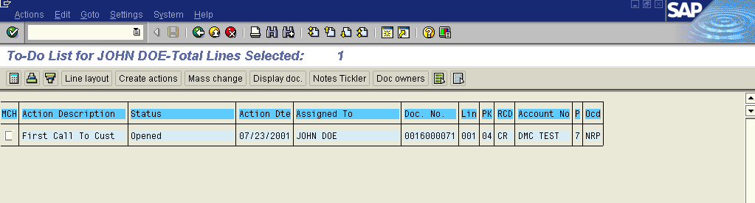

Document List: The Notes Tickler will provide for a user (default Owner) a list of all documents that have been assigned to the particular individual. In addition, if a Notes Selection is chosen (e.g., Action Status equals "O"), the program will display the documents selected that contain open action items.

Documents without Actions: The Notes Tickler will provide a list of all documents that have no actions assigned to them. Furthermore, in the Items Selection Criteria section, the program will select those items that do not contain any of the specified selections.

Other Reports: The Notes Tickler will provide a customizable reporting tree for which a client may develop and store additional Notes Tickler reports.

There are many, many selection criteria for the Deduction Management Component reporting. The selection criteria include document number, company code, credit control area, fiscal year, account number, name assigned to, date assigned to, action status, action code, action date, created by, created on, priority, outcome code, open items, cleared items, among others.

Note: When changing an item or multiple items, all data fields can be changed. With the use of the Deduction Management Component's Field Group Authorizations, however, each field on a Notes Tickler item can be secured from changes. Thus, changes to certain fields can be allowed for only specified persons. See the Deduction Management Component's Help Documentation for details of the Authorization Objects used and for the Super User Profile and Authorizations provided.

Yet another plus with the Deduction Management Component is that it’s completely compatible with SAP R/3 releases from 3.1H to 4.6C. It is an extension of the core R/3 system and offers compatibility across business functions. When installed, the Deduction Management Component is fully integrated with the R/3 system. It was developed in the SAP ABAP programming language and is available for all operating systems and database combinations supported by R/3.

As you can see, the Deduction Management Component functionality is something that is probably needed at every client that deals with customers who don’t completely pay their bills, which would probably be just about every SAP FI installation out there. The reason the functionality isn’t in core SAP R/3 is that in Europe (remember, we are a German-based company), companies pay their bills in full and then dispute any questionable amounts. At least that’s the way it was back in 1972 when SAP started business. This could very well have changed in the recent past. But we know for sure that in North America, the reaction of customers is to pay what they think they owe and wait for a call asking for more money. As I stated earlier, I know … I’ve been there and made those calls. The Deduction Management Component functionality will assist you in being able to track those outstanding receivables and getting that money in your door.

To learn more about the Deduction Management Component and other Global
Solution Center offerings, inside the U.S. call (866) 633-3413, or internationally
call (610) 633-3413. Or you can find additional information online at www.sap.com/globalsolutioncenter or http://service.sap.com/globalsolutioncenter
(SAP Service Marketplace).

Keith Hibbitts is a SAP Platinum Consultant based in SAP’s Dallas, Texas office specializing in the Financial and Controlling modules of SAP R/3, as well as Business Warehouse (BW) and Strategic Enterprise Management (SEM). He has been with SAP America, Inc. since April, 1996. He has an undergraduate degree in Accounting from the Texas A&M — Corpus Christi in Corpus Christi, Texas, and a master’s degree in Business Administration from the Cox School of Business at Southern Methodist University in Dallas, Texas.

